Ex. No. 4 | Webpage Design using Advanced CSS3
Date of Exercise | 31.08.2026
GitHub Host Link | https://praneettigga.github.io/web-tech-lab/
Aim
To design and develop the Consultation (booking) page of the Zen Spaces Interior Design Studio website using HTML5 form elements and CSS3, with a variety of input types, built-in validation attributes and a styled layout, and to link it with the Home, Gallery, Projects, About Us and Contact pages of the same website.
Description
HTML form: The <form> element collects the details of a customer who wants to book a design consultation. The form is divided into three section boxes (Your Details, Your Design Project and Additional Information), and the labels and fields inside each box are aligned using a two-column table.
Input types: The type attribute of <input> selects the kind of control: text, email, password, tel, number, date, month, time, url, search, color, range, file, radio and checkbox. Each type gives the browser a suitable keyboard or picker, for example a calendar for date, a colour chooser for color and a slider for range. <select> with <option> gives drop-down lists, <textarea> gives a multi-line address box, and <input list> with <datalist> offers suggestions while still allowing the user to type a new style.
Validation and helper attributes: The required attribute stops the form from being submitted when the name, email, password or consent check box is empty, and type="email" and type="url" check the format of the value. min and max limit the number of years to 0–100 and the project size slider to 1–10. placeholder shows a sample value inside an empty field, and name="ownership" groups the radio buttons so that only one can be chosen.
Styling the form with CSS3: form.css gives the form container a fixed width, centred with margin: 30px auto, a border, a gold left border, border-radius and box-shadow so it looks like a card. One grouped attribute selector (.consultation-form input[type="text"], input[type="email"], select, textarea and so on) applies the same width, padding, border, background and font to every text-like field, and resize: vertical lets the address box grow only in height. The section boxes have a light background, the section titles are bold, and the Request Consultation button has its own colour with a darker-to-lighter :hover effect.
Home page and other pages: home.html contains the navigation bar, a hero section, a welcome text, a projects table, definition, ordered and unordered lists for the services, and the contact links. Gallery, Projects, About Us and Contact pages use the same navigation bar, with the .current-page class highlighting the open page.
External stylesheets and layout: The CSS is divided by purpose: base.css (page-wide defaults such as box-sizing and fonts), navbar.css (a flexbox navigation bar with a hover colour), layout.css (card sections and table styles) and gallery.css (a CSS Grid of two equal columns for the pictures). Each page links only the files it needs with <link rel="stylesheet">, so the same green and beige theme is shared by all pages.
Procedure:
1. Select the website theme: an Interior Design Studio named Zen Spaces with the pages Home, Gallery, Projects, About Us, Contact and Consultation.
2. Create a folder Expt4 with the sub-folders pages, styles and images, and place the four interior pictures in the images folder.
3. Create styles/base.css, styles/navbar.css and styles/layout.css for the common fonts, colours, navigation bar, cards and tables used by every page.
4. Create pages/form.html with the navigation bar and a form container holding a heading and a short introduction.
5. Inside the form, add the section box Your Details with a table of fields: text (required), text with placeholder, email, password, tel, number (min and max), date and radio buttons.
6. Add the section box Your Design Project with the drop-down lists for Property Type and Design Service, the Preferred Style field with a datalist and the Inspiration Link url field.
7. Add the section box Additional Information with check boxes, a file upload, a search field, month, time, colour and range inputs, the address textarea and the required consent check box.
8. Add the Request Consultation submit button, then create styles/form.css to style the container, section boxes, table cells, all the input types, the textarea and the button.
9. Create home.html with the hero section, welcome text, projects table, lists of services and contact links, and link it to the Consultation page from the navigation bar.
10. Create pages/gallery.html (with styles/gallery.css), pages/about-us.html, pages/contact.html and pages/projects.html using the same navigation bar.
11. Open the Consultation page in a browser, fill in the fields and press the submit button to check the validation messages, and then check the navigation links of all pages.
12. Push the code to GitHub and host it using GitHub Pages to obtain the deployment link.
Program
pages/form.html
<!doctype html>
<html lang="en">
<head>
<meta name="viewport" content="width=device-width, initial-scale=1.0" charset="UTF-8">
<title>Book a Consultation | Zen Spaces</title>
<link rel="stylesheet" href="../styles/base.css">
<link rel="stylesheet" href="../styles/navbar.css">
<link rel="stylesheet" href="../styles/layout.css">
<link rel="stylesheet" href="../styles/form.css">
<link rel="stylesheet" href="../styles/responsive.css">
</head>

<body>
<div class="navbar" id="top">
<h1>ZEN SPACES</h1>
<ul>
<li><a href="../home.html">Home</a></li>
<li><a href="gallery.html">Gallery</a></li>
<li><a href="projects.html">Projects</a></li>
<li><a href="about-us.html">About Us</a></li>
<li><a href="contact.html">Contact</a></li>
<li><a class="current-page" href="form.html">Consultation</a></li>
</ul>
<hr>
</div>

<div class="form-container">
<h2>Book a Design Consultation</h2>
<p>Tell us a little about your home and the space you would like to transform.</p>

<form class="consultation-form">
<div class="section-box">
<div class="section-title">Your Details</div>

<table>
<tr>
<td>Full Name</td>
<td><input type="text" placeholder="Enter your name" required></td>
</tr>
<tr>
<td>Project Reference</td>
<td><input type="text" placeholder="ZS-2026-000"></td>
</tr>
<tr>
<td>Email</td>
<td><input type="email" required></td>
</tr>
<tr>
<td>Create Password</td>
<td><input type="password" required></td>
</tr>
<tr>
<td>Phone Number</td>
<td><input type="tel" placeholder="9876543210"></td>
</tr>
<tr>
<td>Years in Your Home</td>
<td><input type="number" min="0" max="100"></td>
</tr>
<tr>
<td>Preferred Consultation Date</td>
<td><input type="date"></td>
</tr>
<tr>
<td>Home Ownership</td>
<td>
<input type="radio" name="ownership"> Owner
<input type="radio" name="ownership"> Tenant
<input type="radio" name="ownership"> Other
</td>
</tr>
</table>
</div>

<div class="section-box">
<div class="section-title">Your Design Project</div>

<table>
<tr>
<td>Property Type</td>
<td>
<select>
<option>Apartment</option>
<option>Independent House</option>
<option>Villa</option>
<option>Office</option>
<option>Retail Space</option>
</select>
</td>
</tr>
<tr>
<td>Design Service</td>
<td>
<select>
<option>Living Room</option>
<option>Bedroom</option>
<option>Kitchen</option>
<option>Dining Room</option>
<option>Complete Home</option>
</select>
</td>
</tr>
<tr>
<td>Preferred Style</td>
<td>
<input list="styles" placeholder="Choose or type a style">
<datalist id="styles">
<option>Modern</option>
<option>Minimalist</option>
<option>Contemporary</option>
<option>Scandinavian</option>
<option>Classic</option>
</datalist>
</td>
</tr>
<tr>
<td>Inspiration Link</td>
<td><input type="url" placeholder="https://example.com"></td>
</tr>
</table>
</div>

<div class="section-box">
<div class="section-title">Additional Information</div>

<table>
<tr>
<td>Rooms to Design</td>
<td>
<input type="checkbox"> Living Room
<input type="checkbox"> Bedroom
<input type="checkbox"> Kitchen
<input type="checkbox"> Dining Room
</td>
</tr>
<tr>
<td>Floor Plan</td>
<td><input type="file"></td>
</tr>
<tr>
<td>Search a Design Need</td>
<td><input type="search" placeholder="Storage, lighting, furniture..."></td>
</tr>
<tr>
<td>Preferred Completion Month</td>
<td><input type="month"></td>
</tr>
<tr>
<td>Preferred Consultation Time</td>
<td><input type="time"></td>
</tr>
<tr>
<td>Accent Colour</td>
<td><input type="color"></td>
</tr>
<tr>
<td>Project Size</td>
<td><input type="range" min="1" max="10"></td>
</tr>
<tr>
<td>Property Address</td>
<td><textarea rows="4" placeholder="Enter your address"></textarea></td>
</tr>
<tr>
<td></td>
<td><input type="checkbox" required> I agree to be contacted by Zen Spaces about this enquiry.</td>
</tr>
</table>
</div>

<div class="buttons">
<button type="submit">Request Consultation</button>
</div>
</form>
</div>
</body>
</html>
styles/form.css
.form-container {
width: 700px;
margin: 30px auto;
padding: 20px;
border: 1px solid #d8ccb4;
border-left: 5px solid #c5a56a;
border-radius: 10px;
background: #fffdf8;
box-shadow: 0 4px 12px rgba(31, 77, 58, 0.08);
}

.form-container h2 {
margin-top: 0;
padding-bottom: 8px;
border-bottom: 2px solid #d8ccb4;
}

.consultation-form table {
width: 100%;
}

.consultation-form td {
padding: 8px;
vertical-align: top;
}

.consultation-form input[type="text"],
.consultation-form input[type="email"],
.consultation-form input[type="password"],
.consultation-form input[type="number"],
.consultation-form input[type="date"],
.consultation-form input[type="tel"],
.consultation-form input[type="url"],
.consultation-form input[type="search"],
.consultation-form select,
.consultation-form textarea {
width: 95%;
padding: 6px;
border: 1px solid #b8a98a;
border-radius: 4px;
background: #fffdf8;
color: #314339;
font-family: Georgia, serif;
}

.consultation-form textarea {
resize: vertical;
}

.section-box {
margin-bottom: 20px;
padding: 12px;
border: 1px solid #d8ccb4;
background: #f8f5ef;
}

.section-title {
margin-bottom: 10px;
color: #244232;
font-weight: bold;
}

.buttons {
text-align: center;
}

button {
margin: 5px;
padding: 8px 18px;
border: 1px solid #244232;
border-radius: 4px;
background: #244232;
color: #fffaf0;
font-family: Georgia, serif;
}

button:hover {
background: #496b55;
}
home.html
<!DOCTYPE html>
<!--URK24CS1040-->
<!--Website Theme : Interior Design Studio-->
<html lang="en">
<head>
<meta name="viewport" content="width=device-width, initial-scale=1.0" charset="UTF-8">
<title>Interior Design Studio</title>

<link rel="stylesheet" href="styles/base.css">
<link rel="stylesheet" href="styles/navbar.css">
<link rel="stylesheet" href="styles/layout.css">
<link rel="stylesheet" href="styles/responsive.css">
</head>
<body>

<!-- Navigation Section -->
<div class="navbar" id="top">
<h1>ZEN SPACES</h1>
<ul>
<li><a class="current-page" href="#home">Home</a></li>
<li><a href="pages/gallery.html">Gallery</a></li>
<li><a href="#projects">Projects</a></li>
<li><a href="pages/about-us.html">About Us</a></li>
<li><a href="pages/contact.html">Contact</a></li>
<li><a href="pages/form.html">Consultation</a></li>
</ul>
<hr>
</div>

<!-- Hero Section -->
<div class="hero-section" id="home">
<h1>India's Most Trusted Interior Company</h1>
<h2>Crafting Elegant and Functional Interior Design</h2>
<h2>Kitchen | Bedroom | Living | Dining</h2>
<a href="https://github.com/praneettigga/web-tech-lab" target="_blank" rel="noopener noreferrer">
<img src="images/interior-1.jpg" alt="Modern Living Room Interior" width="300">
</a>
<p><a href="#projects">View Our Projects</a></p>
<hr>
</div>

<!-- Welcome Section -->
<div class="welcome-section" id="welcome">
<h3>Welcome to Zen Spaces</h3>
<h4>Welcome to our award winning Interior Design Studio</h4>
<p>
We specialize in creating stylish, innovative, and functional interiors that blend
creative aesthetics with practical design solutions.
</p>
<p>
Every space we design is thoughtfully crafted to reflect our clients’ personality and
lifestyle, while maintaining a modern and sophisticated look.
</p>
<p>
With a fresh perspective and high-end execution, we turn ideas into inspiring spaces.
</p>
<p>You can visit this website's GitHub at:</p>
<a href="https://github.com/praneettigga/web-tech-lab" target="_blank" rel="noopener noreferrer">GitHub</a>
</div>

<!-- Project Section -->
<div class="project-section" id="projects">
<h3>Projects</h3>
<p>Here are some of our featured interior design projects.</p>

<table>
<tr>
<th>Project Image</th>
<th>Project Name</th>
<th>Room Type</th>
<th>Style</th>
</tr>
<tr>
<td>
<a href="https://github.com/praneettigga/web-tech-lab" target="_blank" rel="noopener noreferrer">
<img src="images/interior-1.jpg" alt="Modern living room interior project" width="200">
</a>
</td>
<td>Urban Elegance</td>
<td>Living Room</td>
<td>Modern</td>
</tr>
<tr>
<td>
<a href="https://github.com/praneettigga/web-tech-lab" target="_blank" rel="noopener noreferrer">
<img src="images/interior-2.jpg" alt="Elegant bedroom interior project" width="200">
</a>
</td>
<td>Serene Retreat</td>
<td>Bedroom</td>
<td>Minimalist</td>
</tr>
<tr>
<td>
<a href="https://github.com/praneettigga/web-tech-lab" target="_blank" rel="noopener noreferrer">
<img src="images/interior-3.jpg" alt="Contemporary dining room interior project" width="200">
</a>
</td>
<td>Golden Feast</td>
<td>Dining Room</td>
<td>Contemporary</td>
</tr>
</table>
</div>

<!-- Services and Design Details Section -->
<div class="services-section" id="services">
<h3>Our Services and Design Process</h3>
<p>Zen Spaces offers complete interior design solutions for modern homes and apartments.</p>

<dl>
<dt>Modular Kitchen</dt>
<dd>Smart kitchen layouts with modern cabinets, storage units, and elegant finishes.</dd>

<dt>Bedroom Interiors</dt>
<dd>Comfortable and stylish bedroom designs with wardrobes, lighting, and custom furniture.</dd>

<dt>Living Room Design</dt>
<dd>Beautiful living spaces designed for comfort, family interaction, and visual appeal.</dd>
</dl>

<ol>
<li>Design Consultation
<ol>
<li>Understand client requirements</li>
<li>Discuss budget and space planning</li>
</ol>
</li>
<li>Concept Development
<ol>
<li>Create layout ideas</li>
<li>Select materials and colors</li>
</ol>
</li>
<li>Execution
<ol>
<li>Install furniture and decor</li>
<li>Complete final finishing</li>
</ol>
</li>
</ol>

<ul>
<li>Rooms We Design
<ul>
<li>Living Room</li>
<li>Bedroom</li>
<li>Dining Room</li>
</ul>
</li>
<li>Design Styles
<ul>
<li>Modern</li>
<li>Minimalist</li>
<li>Contemporary</li>
</ul>
</li>
</ul>
</div>

<!-- Contact Section -->
<div class="contact-section" id="contact-home">
<h3>Contact Us</h3>
<p>Email: <a href="mailto:customerservice@zenspaces.com">customerservice@zenspaces.com</a></p>
<p>Phone: <a href="tel:+9123456789">+91 23456 789</a></p>
</div>

</body>
</html>
styles/base.css
body {
margin: 0;
padding: 0;
font-family: Georgia, serif;
color: #314339;
background: #f4f0e7;
}

* {
box-sizing: border-box;
}

img,
video,
iframe {
max-width: 100%;
height: auto;
}

img {
border-radius: 8px;
}

a {
color: #496b55;
}

h1,
h2,
h3,
h4 {
color: #244232;
}

body > h1 {
margin: 28px 20px 0;
padding: 0 0 10px;
border-bottom: 2px solid #c5a56a;
}
styles/navbar.css
.navbar {
margin: 0;
padding: 20px;
border-bottom: 4px solid #c5a56a;
background: #244232;
color: white;
box-shadow: 0 4px 12px rgba(31, 77, 58, 0.12);
}

.navbar h1,
.navbar a {
color: #fffaf0;
}

.navbar a:hover {
color: #e2c98e;
}

.navbar a.current-page {
color: #e2c98e;
}

.navbar ul {
display: flex;
flex-wrap: wrap;
gap: 10px 15px;
list-style: none;
padding: 0;
margin: 0;
}

.navbar li {
margin-right: 0;
}

.navbar hr {
border: 0;
border-top: 1px solid #708573;
}
styles/layout.css
.hero-section,
.welcome-section,
.project-section,
.services-section,
.contact-section,
.page-card {
margin: 20px;
padding: 20px;
border-radius: 10px;
border: 1px solid #d8ccb4;
border-left: 5px solid #c5a56a;
background: #fffdf8;
box-shadow: 0 4px 12px rgba(31, 77, 58, 0.08);
}

.hero-section {
background: #e7ede4;
}

.hero-section h1 {
margin-top: 0;
}

.hero-section img {
border: 4px solid #fffdf8;
box-shadow: 0 4px 12px rgba(31, 77, 58, 0.12);
}

.welcome-section h3,
.project-section h3,
.services-section h3,
.contact-section h3 {
margin-top: 0;
padding-bottom: 8px;
border-bottom: 2px solid #d8ccb4;
}

.services-section dt {
color: #244232;
}

.services-section dd {
margin-bottom: 14px;
}

table {
width: 100%;
border-collapse: collapse;
overflow: hidden;
border-radius: 14px;
}

th,
td {
border: 1px solid #d8ccb4;
padding: 10px;
}

th {
background: #244232;
color: #fffaf0;
}

td {
background: #fffdf8;
}
pages/gallery.html
<!DOCTYPE html>
<html lang="en">
<head>
<meta name="viewport" content="width=device-width, initial-scale=1.0" charset="UTF-8">
<title>Gallery</title>
<link rel="stylesheet" href="../styles/base.css">
<link rel="stylesheet" href="../styles/navbar.css">
<link rel="stylesheet" href="../styles/layout.css">
<link rel="stylesheet" href="../styles/gallery.css">
<link rel="stylesheet" href="../styles/responsive.css">
</head>

<body>

<!-- Navigation Section -->
<div class="navbar" id="top">
<h1>ZEN SPACES</h1>
<ul>
<li><a href="../home.html">Home</a></li>
<li><a class="current-page" href="gallery.html">Gallery</a></li>
<li><a href="projects.html">Projects</a></li>
<li><a href="about-us.html">About Us</a></li>
<li><a href="contact.html">Contact</a></li>
<li><a href="form.html">Consultation</a></li>
</ul>
<hr>
</div>

<h1>Gallery Page</h1>

<ul class="gallery-grid">
<li><img src="../images/interior-1.jpg" alt="Modern living room interior"></li>
<li><img src="../images/interior-2.jpg" alt="Elegant bedroom interior"></li>
<li><img src="../images/interior-3.jpg" alt="Stylish dining room interior"></li>
<li><img src="../images/interior-4.jpg" alt="Luxury modular kitchen interior"></li>
</ul>
</body>
</html>
styles/gallery.css
.gallery-grid {
display: grid;
grid-template-columns: repeat(2, minmax(0, 1fr));
gap: 20px;
padding: 20px;
list-style: none;
}

.gallery-grid li {
min-width: 0;
padding: 10px;
border: 1px solid #d8ccb4;
border-radius: 10px;
background: #fffdf8;
box-shadow: 0 4px 12px rgba(31, 77, 58, 0.08);
}

.gallery-grid img {
display: block;
width: 100%;
}
pages/about-us.html
<!DOCTYPE html>
<html lang="en">
<head>
<meta name="viewport" content="width=device-width, initial-scale=1.0" charset="UTF-8">
<title>About Us</title>
<link rel="stylesheet" href="../styles/base.css">
<link rel="stylesheet" href="../styles/navbar.css">
<link rel="stylesheet" href="../styles/layout.css">
<link rel="stylesheet" href="../styles/responsive.css">
</head>

<body>

<!-- Navigation Section -->
<div class="navbar" id="top">
<h1>ZEN SPACES</h1>
<ul>
<li><a href="../home.html">Home</a></li>
<li><a href="gallery.html">Gallery</a></li>
<li><a href="projects.html">Projects</a></li>
<li><a class="current-page" href="about-us.html">About Us</a></li>
<li><a href="contact.html">Contact</a></li>
<li><a href="form.html">Consultation</a></li>
</ul>
<hr>
</div>

<h1>About Us</h1>

<div class="page-card">
<p>“Made for you” may be an accurate phrase to express what we do in interiors. We have been designing and executing exquisite home interiors since 2004. Custom-made interior is the best way to ensure that modular kitchen, wardrobes and other furniture perfectly fits to the spaces. Our interior designers possess impeccable ability to understand client’s requirements and provide the best space planning for a house or flat. D’LIFE’s fully equipped modular kitchen is distinct with its unique design and most modern features. We plan and make contemporary style furniture for bedrooms, living and dining rooms as well. Innovative ideas, creative designs and ability to deliver the promises on time enables us to retain the leadership in this field.</p>
</div>

</body>
</html>
pages/contact.html
<!DOCTYPE html>
<html lang="en">
<head>
<meta name="viewport" content="width=device-width, initial-scale=1.0" charset="UTF-8">
<title>Contact</title>
<link rel="stylesheet" href="../styles/base.css">
<link rel="stylesheet" href="../styles/navbar.css">
<link rel="stylesheet" href="../styles/layout.css">
<link rel="stylesheet" href="../styles/responsive.css">
</head>

<body>

<!-- Navigation Section -->
<div class="navbar" id="top">
<h1>ZEN SPACES</h1>
<ul>
<li><a href="../home.html">Home</a></li>
<li><a href="gallery.html">Gallery</a></li>
<li><a href="projects.html">Projects</a></li>
<li><a href="about-us.html">About Us</a></li>
<li><a class="current-page" href="contact.html">Contact</a></li>
<li><a href="form.html">Consultation</a></li>
</ul>
<hr>
</div>

<div class="page-card">
<h1>Contact The Best Home Interior Designers at:</h1>
<a href = "mailto:customerservice@zenspaces.com">Email: customerservice@zenspaces.com</a>
<br>
<a href = "tel:+9123456789">Phone: +9123456789</a>
</div>

</body>
</html>
pages/projects.html
<!DOCTYPE html>
<html lang="en">
<head>
<meta name="viewport" content="width=device-width, initial-scale=1.0" charset="UTF-8">
<title>Projects</title>
<link rel="stylesheet" href="../styles/base.css">
<link rel="stylesheet" href="../styles/navbar.css">
<link rel="stylesheet" href="../styles/layout.css">
<link rel="stylesheet" href="../styles/responsive.css">
</head>

<body>

<!-- Navigation Section -->
<div class="navbar" id="top">
<h1>ZEN SPACES</h1>
<ul>
<li><a href="../home.html">Home</a></li>
<li><a href="gallery.html">Gallery</a></li>
<li><a class="current-page" href="projects.html">Projects</a></li>
<li><a href="about-us.html">About Us</a></li>
<li><a href="contact.html">Contact</a></li>
<li><a href="form.html">Consultation</a></li>
</ul>
<hr>
</div>

<h1>Projects Page</h1>

<div class="page-card">
<p>This page is still in progress...</p>
</div>

</body>
</html>
Output
Consultation Page – Top
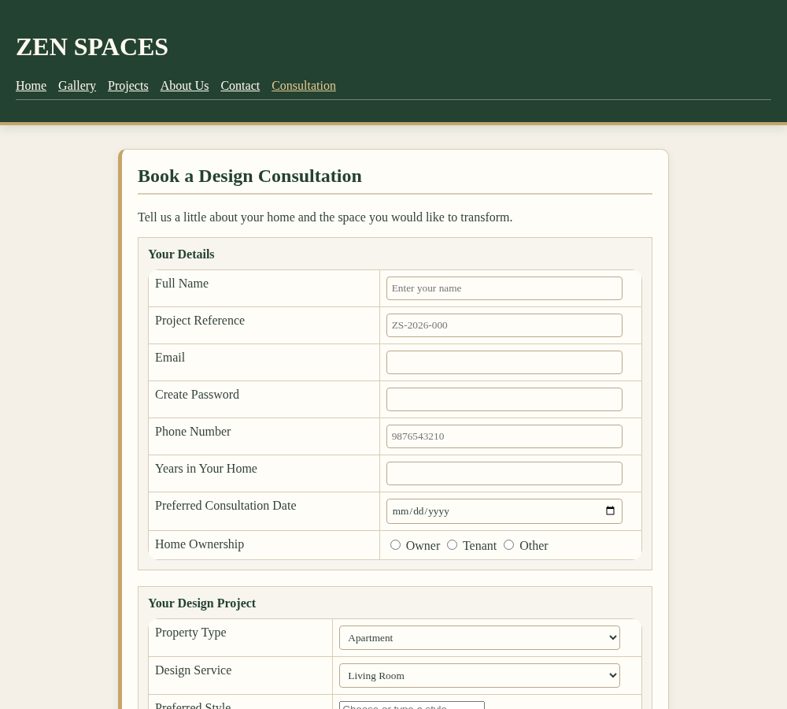
Figure 1: Consultation form (Your Details and Your Design Project)
Consultation Page – Bottom
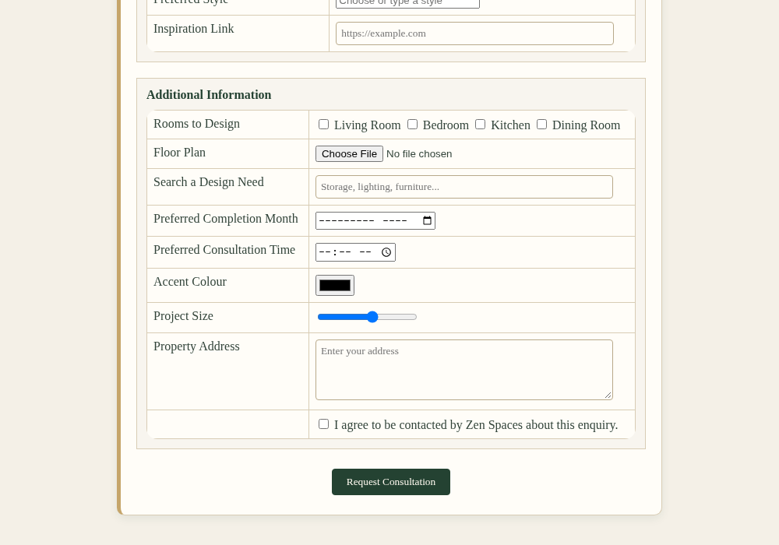
Figure 2: Consultation form (Additional Information)
Home Page – Top Section
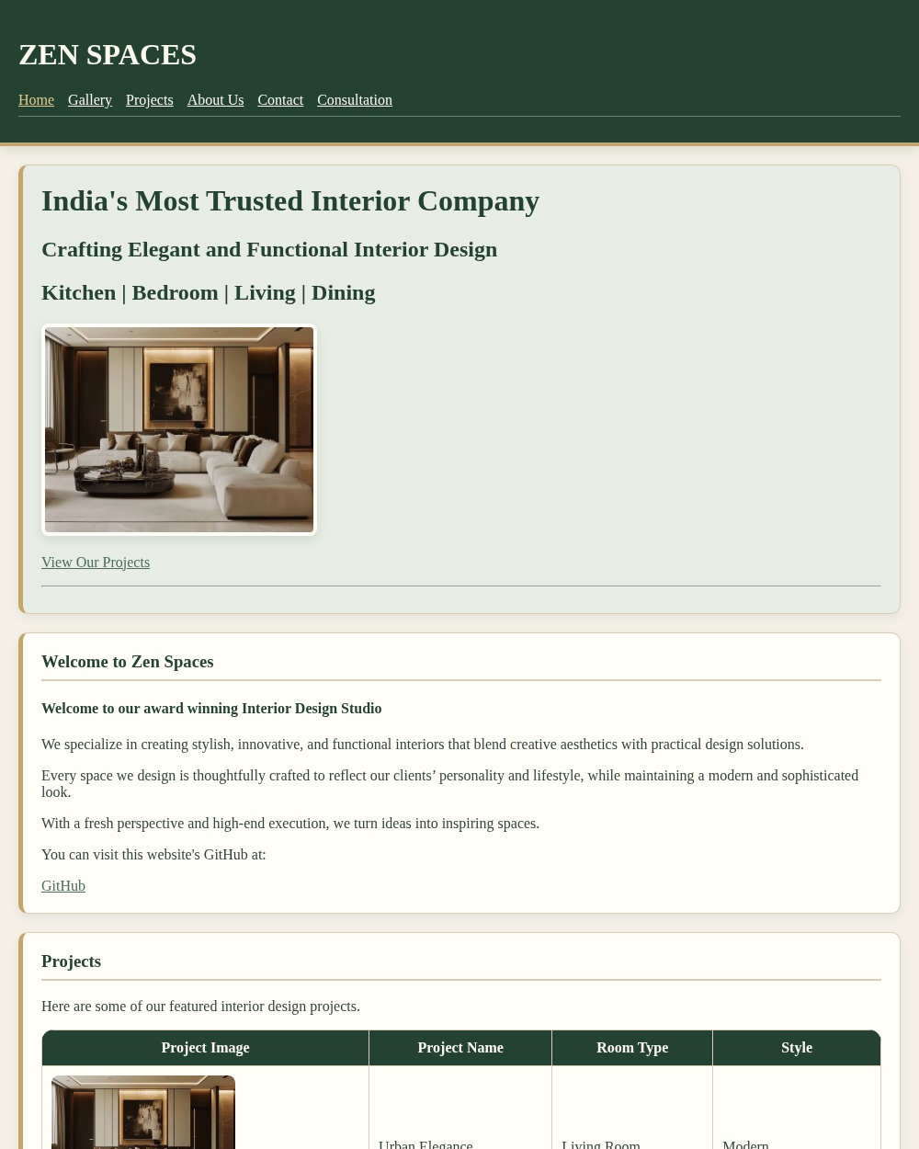
Figure 3: Home page (top section)
Home Page – Lower Sections
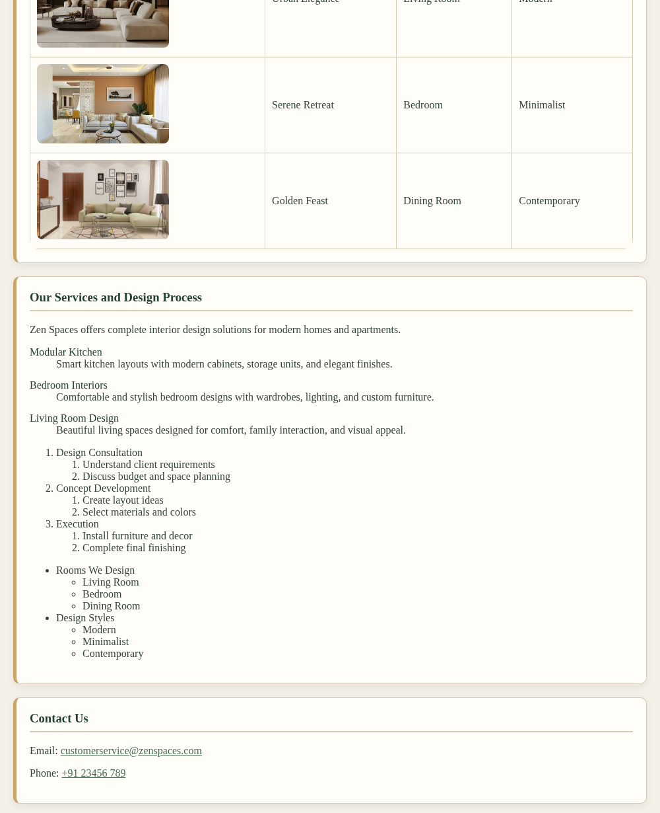
Figure 4: Home page (services and contact)
Gallery Page
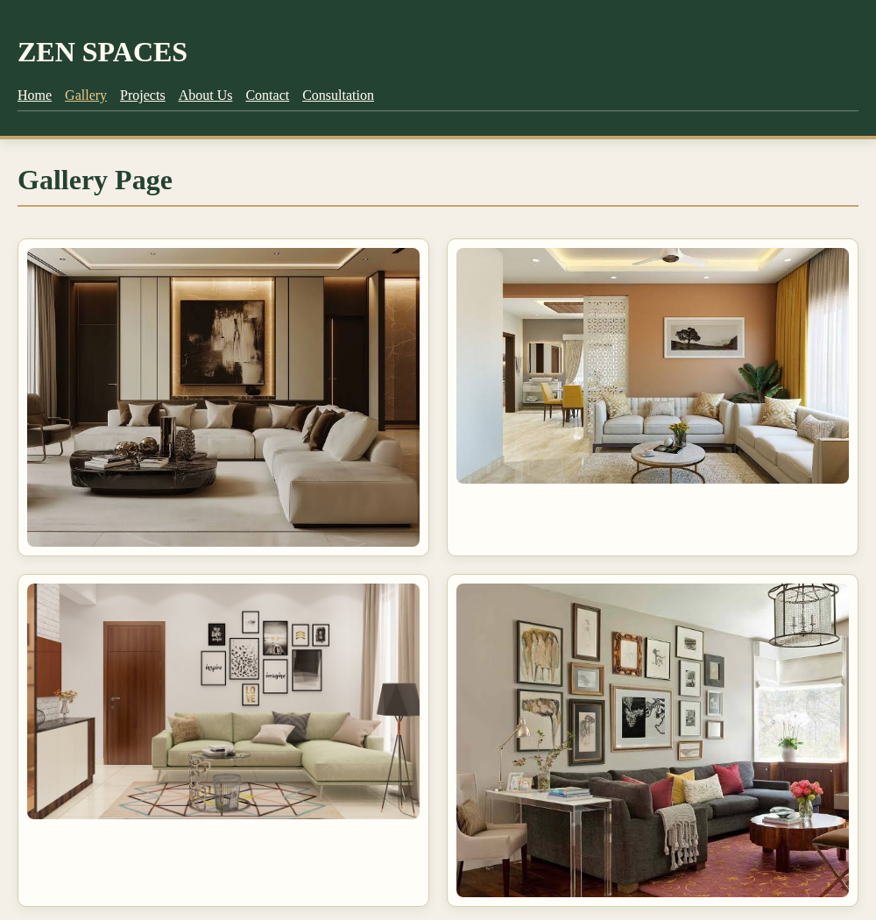
Figure 5: Gallery page (CSS Grid layout)
Projects Page
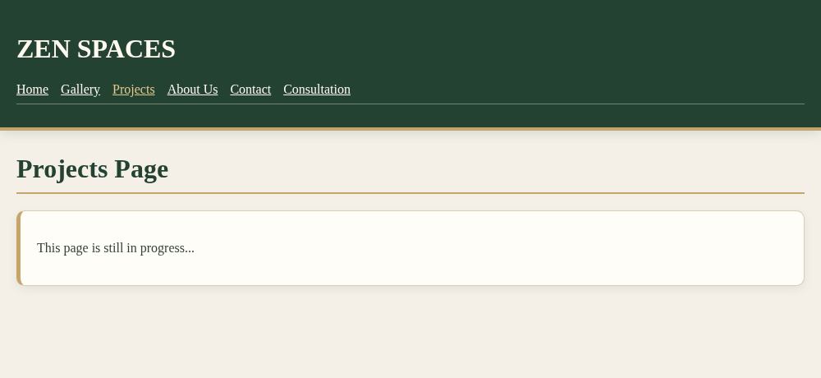
Figure 6: Projects page
About Us Page
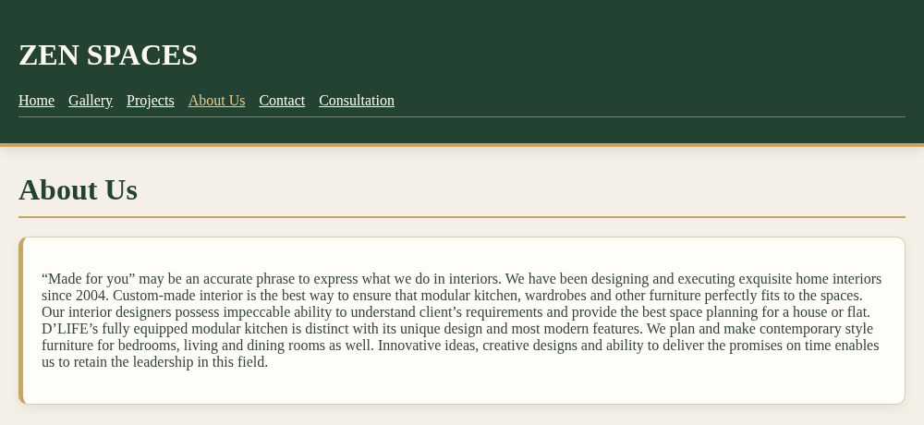
Figure 7: About Us page
Contact Page
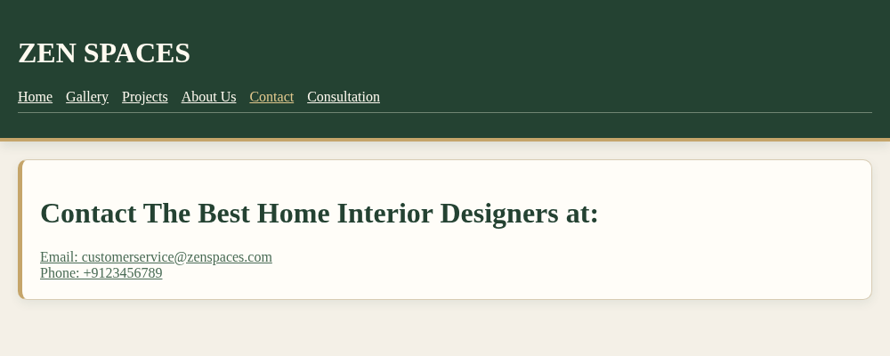
Figure 8: Contact page
Result
The Consultation page of the Zen Spaces website was successfully designed and executed using HTML5 form elements and CSS3. The different input types, drop-down lists, datalist and textarea were displayed with a uniform style, the required fields were validated by the browser before submission, and the page was linked with the Home, Gallery, Projects, About Us and Contact pages.

